Fallout Live Radio Software Design Specifications

Overview

Fallout Live Radio (FLR) is an android app that plays the radios of the video game Fallout 3 in an evolving manner. Unlike all other emulations, FLR will have radio stations whose stories will add and change over real time, unlike all others who simply have the music with random news reports put in between a couple of songs. Additionally, it will include all full stations from the game, unlike most others that only have one, or two at the most. The stations evolve by following the story of a fictional character in the game, who will progress through the story semi-randomly, and listeners can check in daily to hear what’s new in this world.

User Interface

The user interface will be very simplistic, with only a few options at max on the screen at once. The overall theme will coincide with Fallout 3’s theme, which will be retro-futuristic, meaning black background with green text and visuals. An ornamental frame will be the same around every screen, with only the text within the frame changing to make it seem like it’s a retro computer. All the interface options will be straightforward buttons, and the only exception will be all the settings, where there will have to be dropdown menus, sliders, and/or lists.

For reference for the intended look of the application:

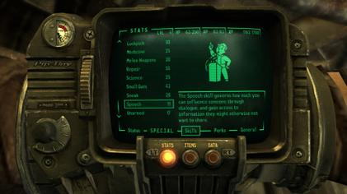

Functionality

When the application is launched, the first screen will be a settings screen with options to change certain variables in background calculations, for example the speed at which the fictional character progresses through the story. There will most likely be a save and load on this screen for multiple fictional characters, so a listener can choose to follow multiple characters who are possibly taking very different paths. Once they load the radio station, it will show the different radio stations, which the listener can switch between freely. There will also be a button to return to the settings screen.

A rough idea of the theory behind the application:

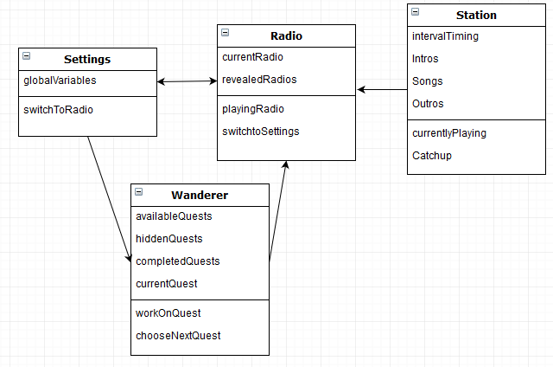

Milestones

First to be developed, because it’s the backbone of the entire app, will be making a way to play sounds for a while, with predetermined intervals and play audio from another set of files.

Next, will be programming the fictional character, specifically, how they progress through the story, and how to keep track of what it’s done and can do.

Next will be combining the two, by having the station interrupt the audio files, and choosing based off what the fictional character has done.

Next will be perfecting the one station, by creating algorithms for figuring out the semi-randomized intros and outros for each report, or when to replace the report with the radio theater.

Next will be adding the other station that is at the start.

Last for the radio will be adding the unlockable radio stations.

Lastly for the operational part, will be adding the setting screens, and optionally adding additional saves.

Finally, once the application operates correctly, visuals will be needed to make it look nice.

Goals

The goal for this application will be for people who enjoyed the video game to have a way to re-live listening to it’s iconic radio stations, and to have stations that make sense instead of a playlist with random sound files. Additionally, for everyone else who’s never played Fallout 3, it’s intended to have a story where someone can listen to on their commutes, long drives, or just want to listen to 60’s music and enjoy a window into another post-apocalyptic world, and how it’s being saved or destroyed by this “wanderer”. This should be an application where a person can listen in a few times a week, and figure out when the scheduled news broadcasts are, and be surprised with the seemingly endless number of changing stories. Hopefully it will hook listeners, make them want to keep coming back, and wanting to hear what is coming tomorrow, or next week.